**Infosys Response for RBS assignment for NPA program – UK :**

|  |  |
| --- | --- |
| **Infosys Profile Details** | **Background / Synopsis** |
| *Anandaraj Ulaganathan <*[*anandaraj.u@infosys.com*](mailto:anandaraj.u@infosys.com)*>* | * 11.9 Years of IT experience in Manual Testing, Mobile Application Testing(Android/IOS), Web Application Testing, **Mobile Automation Testing** using selenium/Appium(JAVA), **Cucumber(BDD) Framework and RestAPI Testing(Manual).** * Expertise in Automated Testing using Testing Tool Selenium WebDriver, **Appium.** * Proficient with **BDD Framework using cucumber.** * Good experience in Developing robust scripts, Debugging and Maintaining the automation scripts. * Effectively provided Test Automation Plans and shared Automation Test Results to Stakeholders. * Having good experience in test analysis, design, manual testing, for development, enhancement and Implementation projects. * Developed BDD tests using Cucumber by writing Feature File and step definitions. Developed required Selenium support code in JAVA for Gherkin scenarios. * Expert in Test management tools like HP ALM, Clear Quest, JIRA and Bugzilla. |

**Assignment Details :**

**OI shopping Implementation steps:**

I have created Cucumber (BDD framework) using Maven with all the required dependencies to automate “OI Shopping” mobile application. The project structure is designed as below to automate the 2 given scenarios.

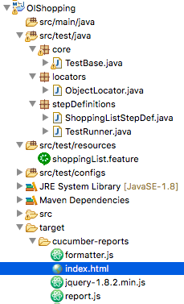

* **ObjectLocator Class** is created to keep all the Object inspected from OI Shopping mobile application
* **TestBase Class**- is created to keep all the reusable methods
* **ShoppingListStepDef Class**- is created to implement and calls the respective method which has the business logic based on the scenarios.
* **ShoppingList.feature** –is created to describe the 2 scenarios from IO shopping Application.
* **TestRunner Class**- is created to glue the feature file with the step definition file.

Scenario 1:

Below scenario is created in ShoppingList.Feature File with tag name @First_scenario

* Create 2 new lists –Created a method adding List () to create the New list using DataTable.
* Add new list items – Created a method addItems () to add items dynamically in selected list using Data Table.
* Delete an item from the list – Created a method deleteItems () to delete the selected item from the selected list.

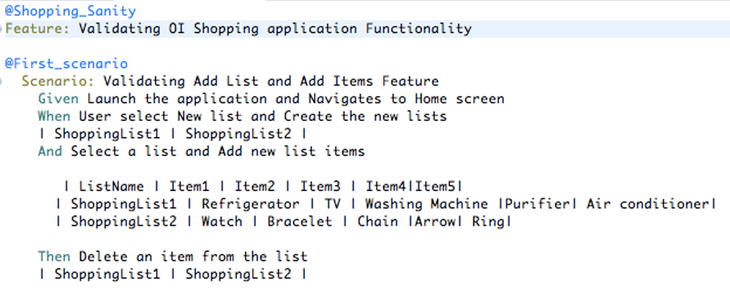

## Scenario 2:

Below scenario is created in ShoppingList.Feature File with tag name @Second_scenario

* Create a list and add items- Reused both addingList () and addItems () method to create a list and adding Items to the selected list using DataTable.
* Sort the list and validate the sorting of the list items- Methods sortList () is created to select a list which consists of list of Items and to sort the items in alphabetical order. Then ValidateList() is created which stores the items created in a list and validate whether the lists are sorted in alphabetical order.

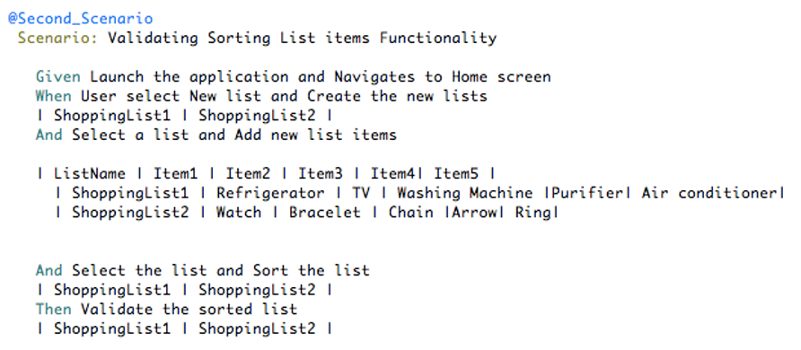

**OI shopping Execution steps:**

IO shopping code is pushed into github public repository in below link.

**Git Path:** <https://github.com/uanandaraj0507/OIShopping_RBS_Assignment>

1.Import the project in Eclipse IDE and Select Maven->Update project to download the required dependencies given in POM.xml file.

2.After successful download, Right click the project and Select RunAs->Junit Test

3.Observe the Output for OIShopping Project in console.

4.Open Target folder->Cucumber-report-> index.html file to see the detailed report.

